Cryptography – Case Study Report
CYBR3030
Identity Management

Arr Domingo
Student ID: 200458099
December 4, 2025

Instructor: Sam El-Awour
Table of Contents

1 Summary 1
2 Network Diagram 1
3 Gap Analysis – Current State and Associated Risks 3
3.1 Danger in storing plaintext credentials 3
3.2 Use of self-signed certificate in data transit 3
3.3 Lack of security for data at rest 3
3.4 Unsecured authorized partner access 4
3.5 Insufficient network segmentation 4
4 Gap Analysis - Recommendations and Justifications 4
4.1 Migrate from plaintext to Argon2 for storing credentials 4
4.2 Use CA-signed certificate instead of self-signed certificate 5
4.3 Use AES-256 for data at rest 6
4.4 Implement API tokens and RBAC for authorized partner access 7
4.5 Add DMZ network zone 7

1 Summary
Due to the sensitive nature of this project, having strong data protection is essential. By implementing cryptography, it enables confidentiality via preventing unauthorized access and protects critical information from being exposed. It guards the integrity of data by making sure that data is not altered or otherwise tampered during the transmission within the Edmonton Main Office and the authorized partners. It also guarantees authenticity by ensuring that users or authorized partners are who they claim to be.
Therefore, this report identifies several security gaps, including the danger in plaintext credentials storage, usage of a self-signed certificate in data transit, lack of security for data at rest, unprotected authorized partner access, and insufficient network segmentation. Moreover, this report provides recommendations for modern cryptographic controls. These protections include the use of Argon2 hashing instead of plaintext in storing important credentials, replacing self-signed certificate with a trusted CA-signed certificate for the data transit, use of AES-256 for databases and file storage, issue unique API tokens as well as implementing RBAC for authorized partners, and add demilitarized (DMZ) zone on the network layout. These changes will significantly enhance data confidentiality, integrity, authenticity, and system resilience.

2 Network Diagram
This is the current network diagram of Edmonton Comics main office which consists of a firewall, load balancer, 3 web servers, and 2 database servers. The firewall is used to protect the network and allow authorized traffic. The network traffic on the web servers is managed by load balancer, and the database servers are clustered for redundancy and fault tolerance purposes.
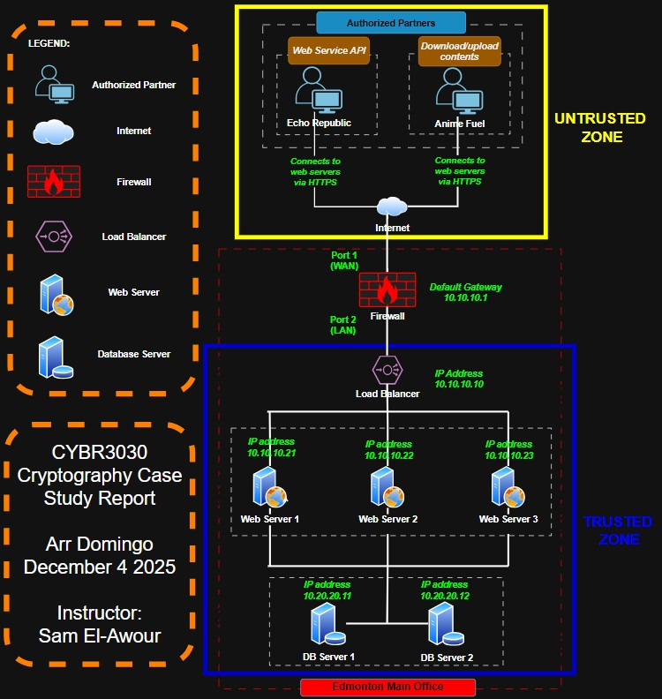
Figure 1. Network Diagram of Edmonton Comics main office.

3 Gap Analysis – Current State and Associated Risks
This section is the evaluation of Edmonton Comics’ current state with the authorized partners to identify the weaknesses or potential risks. This way, a roadmap for improvement will be developed to achieve the general goal of the company. Overall, the desired state would be to safeguard the valuable data of the company.

3.1 Danger in storing plaintext credentials
Current State: Both usernames and passwords on web servers are stored in plaintext form.
Risk: There is a high likelihood of credential theft if servers are compromised. Attackers could gain full unauthorized access.

3.2 Use of self-signed certificate in data transit
Current State: Web servers use a self-signed TLS certificate.
Risk: Partners cannot validate server authenticity, increasing chance of man-in-the-middle attacks.

3.3 Lack of security for data at rest
Current State: Sensitive project files and database content are not encrypted.
Risk: If attackers access storage, sensitive comics and business data could be exposed.

3.4 Unsecured authorized partner access
Current State: The company wants to share and store data securely, however Echo Republic and Anime Fuel rely on web-based access without enforced cryptographic standards.
Risk: Web service API and file transfer increase potential unauthorized access.

3.5 Insufficient network segmentation
Current State: Web servers and databases appear to be closely linked without additional isolation.
Risk: Increases lateral movement risk by attackers making it easier for them to move from a single compromised device to other parts of the network and causes a widespread breach.

4 Gap Analysis - Recommendations and Justifications
This is the action plan that bridges the gap between current state and desired state.

4.1 Migrate from plaintext to Argon2 for storing credentials
The recommended security step is to migrate from plaintext to Argon2 hashing for storing credentials. Argon2 is the best choice for password hashing as it is designed to provide the highest level of security against brute force attacks. It uses memory-hard function, meaning it requires a significant amount of memory to compute.
How it works is it begins by allocating a defined memory size, filling it with pseudo-random values derived from the password, salt, and configuration parameters. Through multiple iterations, Argon2 repeatedly combines the password and salt with the memory’s contents, creating a highly entangled relationship between inputs and outputs. Finally, Argon2 compresses the memory array into a fixed-size output (the hash). This hash securely represents the original password without exposing it. Think of Argon2 like a very strong blender used to mix ingredients into something unrecognizable. Once a password goes into the Argon2 “blender,” it comes out as a long string of random-looking characters where it cannot turn back into the original password. This is the reason why it is extremely hard for hackers to reverse the password because it wastes hacker’s time, computing power, and money.

4.2 Use CA-signed certificate instead of self-signed certificate
It is recommended to replace self-signed certificate to CA-signed certificate because it provides trusted authentication for partners and essential for secure API and file transfer. Using CA-signed certificates ensures trusted identity validation during communications. Digital certificates authenticate server identity to ensure secure web communications, notably for HTTPS connections. They begin with generating a private/public key pair and a Certificate Signing Request (CSR), submitted to a Certificate Authority (CA) for signing. Browsers, pre-installed with CA certificates, use these to verify server certificates during the SSL handshake, enabling encrypted data exchange.
It’s like getting an official ID from the government. Everyone trusts it because a recognized, neutral authority confirmed your identity. This is such a big deal because when partners like Echo Republic or Anime Fuel connect to Edmonton Comics' website, they need to know they’re talking to the real Edmonton Comics server, no hacker is pretending to be the company, and the connection is secure and encrypted. A CA-signed certificate guarantees that devices and browsers automatically trust it, so no warnings pop up, and nobody has to manually verify anything.

4.3 Use AES-256 for data at rest
It is highly recommended to use AES-256 for databases and file storage. Advanced Encryption Standard (AES) 256 uses a 256-bit key to convert plain text into cipher. This ensures that Edmonton Comics’ sensitive comic files, partner transfers, and internal data remain unreadable to anyone who doesn’t have permission, protecting the company’s creative work and business operations.
Encryption works by converting plain text into an unreadable cipher code. AES is a symmetric key cipher that uses the same key for encryption and decryption. Symmetric keys are faster and more efficient than asymmetric keys as they require less computational power. AES encryption divides information to be encrypted into sections called blocks. It involves replacing different bytes, shifting rows and mixing columns, and scrambling the information. The result is a random set of characters that cannot be read without a decryption key. AES-256 completes 14 rounds of encryption to encode data. It offers additional security as it involves a key expansion process. The initial key leads to a series of new keys called round keys. Multiple rounds of modification generate round keys. This process enhances security making it harder for unauthorized users to break the encryption. AES-256 is the longest and strongest encryption. A hacker will have to try 2256 distinct combinations to break the encryption.

4.4 Implement API tokens and RBAC for authorized partner access
The recommendation here is to issue unique API tokens per partner and implement RBAC to control what each partner can access. An API token is a unique identifier used to authenticate a user or application to access an API. It is created by the service provider and must be included in every API request to authorize access to protected resources. API tokens work by using cryptography to generate a unique code that can be verified by the API provider. When a user or application makes a request, the token is included in the request header to authenticate the request. On the other hand, Role-based access control (RBAC) is a security approach that authorizes and restricts system access to users based on their role(s) within an organization. This allows authorized partners to access the data needed to fulfill their job requirements and minimizes the risk of unauthorized access to sensitive information or performing unauthorized tasks.

4.5 Add DMZ network zone
The recommendation is to include an additional protection from untrusted traffic by implementing the demilitarized (DMZ) zone that would separate untrusted zone and trusted zone. By adding DMZ zone in the network, this would isolate the company from external threats because it acts as a protection layer through which outside users cannot access the company’s data. Furthermore, by implementing DMZ, only the data that is intended to be visible publicly is displayed and the rest is hidden and secured. The main importance of DMZ is the protection against external attacks, secure public services, traffic control, and minimized internal network exposure.

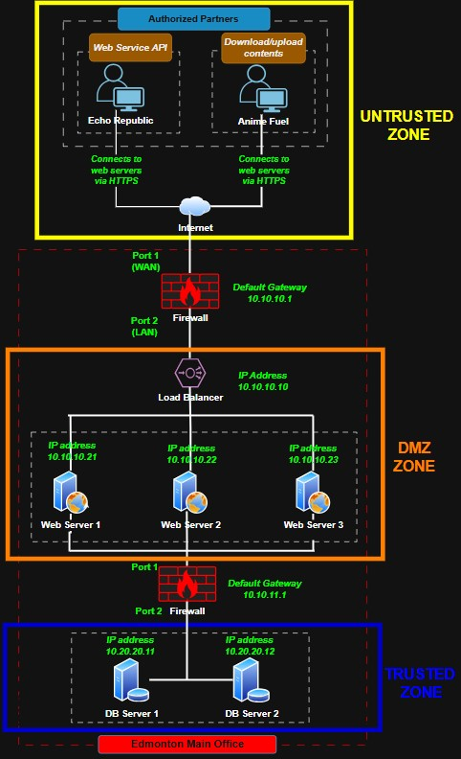
Figure 2. Recommended network diagram with added DMZ zone.

References

Basatwar, G. (2025, March 14). AES-256 Encryption – Everything You Need to Know. Retrieved from Doverunner: https://doverunner.com/blogs/everything-to-know-about-aes-256-encryption/
Beschokov, M. (n.d.). What is an API token? Quick Guide. Retrieved from wallarm: https://www.wallarm.com/what/what-is-an-api-token-quick-guide
Indumwa, D. S. (2024, November 23). Argon2: The Gold Standard for Password Hashing. Retrieved from Douglas Sabwa Indumwa: https://blog.douglas.africa/argon2-the-gold-standard-for-password-hashing
McCarthy, M. (2025, October 23). The Definitive Guide to Role-Based Access Control (RBAC). Retrieved from strongdm: https://www.strongdm.com/rbac
Villanueva, J. C. (n.d.). How do digital certificates work – an overview. Retrieved from jscape: https://www.jscape.com/blog/an-overview-of-how-digital-certificates-work
What Is Argon2? (2025, April 22). Retrieved from jumpcloud: https://jumpcloud.com/it-index/what-is-argon2
What is Demiltarized Zone? (2025, October 3). Retrieved from geeksforgeeks: https://www.geeksforgeeks.org/computer-networks/what-is-demiltarized-zone/
Why cryptography is important and how it’s continually evolving. (2024, December 23). Retrieved from Sectigo: https://www.sectigo.com/blog/cryptography-importance-how-its-changing

